UNIVERSITY AMERICAN COLLEGE SKOPJE

SCHOOL OF COMPUTER SCIENCE AND INFORMATION TECHNOLOGY



Course

DATABASES

Title of the project
Relational Database Design and Implementation: Automated Car Rental Management System



Student: Konstantin Pandilovski, Ivo Sardzovski-Teovski
ID: 6227, 6228
Instructor: Venera Gudachi, PhD

Academic year 2025/2026

Contents:
1. Introduction………………………………………………………………………………………….3
2. Documentation of tables………………………………………………………………………4
3. E-R diagram…………………………………………………………………………………….….10
4. Diagram of tables……………………………………………………………………………….12
5. Refrences

1. Introduction

First and foremost, the main aim of creating this database is to address the logistics involved in managing the fleet and keeping tabs on rentals within the busy automotive service setting. Car rental businesses often have difficulties when it comes to recording accurate information regarding the availability of vehicles, the billing process, and scheduling the pick-up and return times. The database eliminates any potential problem like double booking or mistakes due to manual data entries through the application of a well-structured relational model. It starts from when the client creates a profile and ends with payment upon completion of the rental period.
The design allows for the integration of various users with their own unique sets of permissions. Administrators will need access to all types of data concerning the finances and fleet to examine the profit margins and location efficiency. On the other hand, the front desk personnel will be more interested in operational data as they will need to verify the availability of vehicles, add new customers, and conduct rental transactions. The safety of the data is guaranteed by employing an access control approach that limits access according to the user role.
The rationale behind such a system is rooted in the necessity for automation within a modern technical setting. Absent a powerful database, monitoring of a fleet of cars moving around various cities would be highly inconsistent. This system stores vital information on vehicles, namely the exact specifications of each car, various classes of cars with unique daily rental rates, the contact details of customers, as well as a complete rental and payment history. All data is interconnected using foreign keys in order to guarantee that there is no rental without both a customer and an available car.
We decided to go with Microsoft SQL Server for the database because it’s known for being really reliable and rock-solid. All the work — from creating tables to managing the data — was done in SQL Server Management Studio, or SSMS as most people call it. The database follows a proper relational model and is designed in Third Normal Form (3NF), which keeps everything clean, well-organized, and efficient.
This project is built on certain assumptions, primarily that the car rental company operates across multiple physical branches and that each rental is paid for in a single transaction.
2. Documentation of Tables
1. Basic SELECT with WHERE: Find all cars currently available for rent
This query retrieves the basic details of all vehicles currently marked as 'Available' in the system. The expected result for this specific execution is an empty grid, which serves as functional proof of the database's automation. Because the insertion of the 25 rental records triggered the system to update the status of every corresponding vehicle to 'Rented', there are currently no available cars, demonstrating that the triggers maintain accurate real-time inventory.
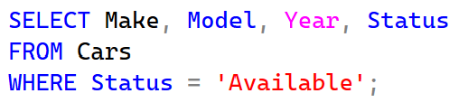

2. INNER JOIN: Display car details alongside their specific category names and rates
The query matches the data in the fleet table and the categories tables through the Category ID field. The output gives an all-inclusive picture of the vehicles that shows the type, the category, and the daily rental cost of each car. The information is important for the front desk when dealing with clients since it enables them to give the exact price for any vehicle selected by the customer.
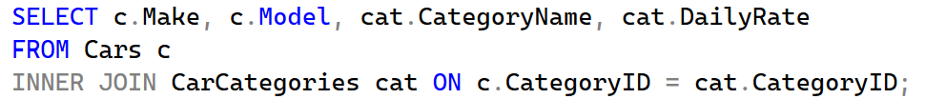

3. LEFT JOIN: List all customers and any rentals they have made (including those with zero rentals)
As a result of using the LEFT JOIN command, all the customers present in the database will be shown, irrespective of whether they have a record of renting vehicles. The output will provide details of each customer’s name and rental date and amount, but where there are no records of rental activities among some of the registered customers, the results will display NULL. Such queries are very important in marketing departments to find out inactive customers.
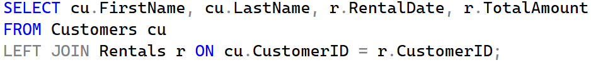
4. GROUP BY with Aggregate: Count how many cars are stationed at each branch location
This query will determine the physical distribution of the fleet among all the branches of the company. The query is performed using both the Locations table and the Cars table, and the results are grouped based on the branch name while the count of the number of cars per branch is made.

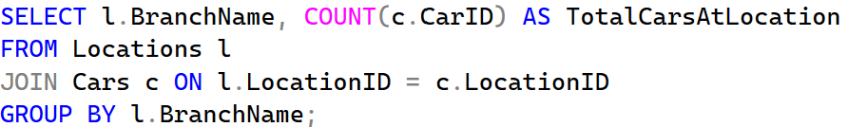

5. Subquery in WHERE: Identify customers who have rented from the 'Luxury' category
This query will determine the physical distribution of the fleet among all the branches of the company. The query is performed using both the Locations table and the Cars table, and the results are grouped based on the branch name while the count of the number of cars per branch is made.
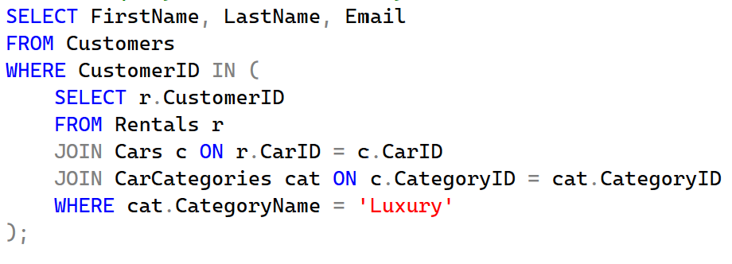
6. Aggregate with HAVING: Find locations that have processed more than 2 rental transactions
This query will help us find out those branches that have higher traffic by grouping the rentals according to their pick-up location using a HAVING clause to exclude those branches that have less than three rental records. This will provide us with important information that could help us make important decisions.
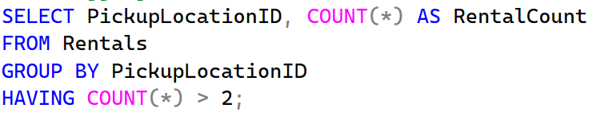
7. Multiple JOINs: Create a complete rental report showing customer, car, and payment details

This comprehensive query connects four separate tables to generate a unified transaction report. The resulting dataset provides a complete narrative of a rental event, detailing who rented the car, exactly which vehicle was taken, the final amount charged, and the payment method used. This is the exact type of query used to generate customer invoices or daily financial summaries.
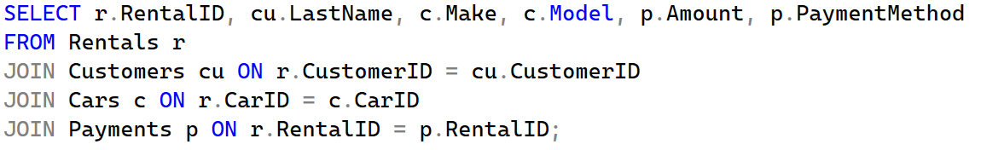
8. Subquery in SELECT: Show each payment amount alongside the total revenue of the company
By placing a subquery directly within the SELECT statement, this query displays individual transaction amounts right next to the grand total of all payments ever collected. The results allow financial analysts to immediately see how a single rental contributes to the company's overall revenue pool without needing to run separate calculations or external reports.
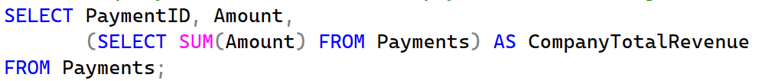
9. Date Function Query: Calculate the duration of each rental in days using DATEDIFF
This query uses SQL’s date functions to calculate exactly how many days a customer had the car. It simply subtracts the start date from the end date to get the precise rental period. Getting this number right is really important — it ensures the total cost matches the daily rate perfectly, so customers pay exactly what they owe.
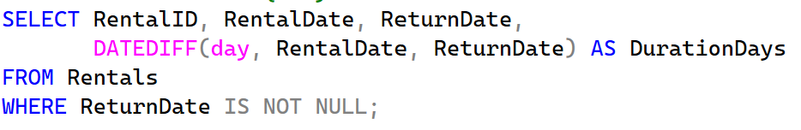
10. Complex Query: Total revenue generated by each car category, sorted from highest to lowest
This analytical query aggregates financial data across multiple table joins to calculate the total income produced by each distinct vehicle class. The results are ordered in descending fashion, placing the most profitable car categories at the top of the grid. Management relies heavily on this type of insight to make informed purchasing decisions for future fleet expansions, investing more in the categories that yield the highest return.
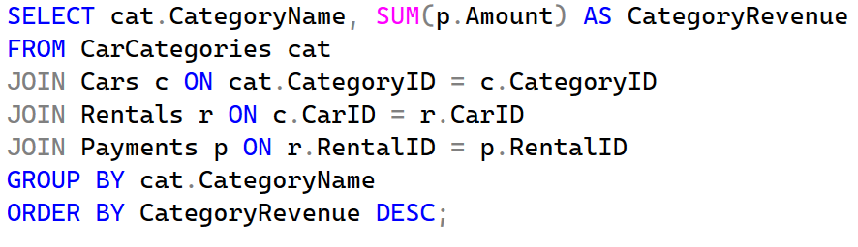

This part provides a detailed overview of the physical implementation of the database schema. The architecture consists of six interconnected tables designed to maintain data integrity and support complex transactional workflows. Each table has been optimized using appropriate data types and constraints to ensure that information—ranging from vehicle specifications to financial records—is stored accurately and securely. The following documentation details the purpose, column structure, and relational dependencies of each table.
Table 1: CarCategories:
The CarCategories table serves as a foundational lookup table for the entire system. Its primary role is to define the various tiers of vehicles available for rent (e.g., Economy, SUV, Luxury) and their associated pricing. By separating these details from the individual car records, the system avoids redundancy and allows for global pricing updates. The CategoryID is the Primary Key, ensuring each category is unique.

Table 2: Locations:
The Locations table manages the physical infrastructure of the rental business. It stores the branch name, city, and address for every site where a vehicle can be picked up or dropped off. This table is essential for multi-branch operations, as it allows the system to track exactly where every car in the fleet is currently stationed.

Table 3: Customers
The Customers table contains the personal details of all those customers who have enrolled themselves within the system. They have IDs, their contact numbers, and names. The quality of data is assured with columns such as Emails as they are set to unique indexes, hence not allowing any duplicate registration. The Customers table acts as a parent table to the Rentals table.

Table 4: Cars
The cars table forms the core data source containing the fleet of vehicles, which have particular properties such as brand name, model, year, and registration number. The tables uses several foreign keys: CategoryID to retrieve the price per hour based on the type of car, and LocationID indicating the particular branch where the vehicle is housed. The Status property is automatically updated using triggers, indicating if a car is rented or not.

Table 5: Rentals
The Rental table forms the central transactional core of the database. It records the "transaction event," which refers to the renting of a particular car by a specific client. It documents the rental period, pick-up point, and delivery point. Since this table links almost all other tables within the database, it forms the basis for operations reports and history reports.
Table 6: Payments
The Payments table handles the financial completion of the rental lifecycle. Each record in this table is linked to a specific RentalID, ensuring that every payment is accounted for against a verified transaction. By separating payments into their own table, the system can support different payment methods (Credit Card, Cash, etc.) while keeping the rental transaction history clean and focused on logistics.
Relationships and Integrity:
This system uses the concept of "One-to-Many" relationships between these entities. The examples here would be that one Location may have several Cars, while one Customer may generate several Rentals. Foreign Key constraints help achieve this by making sure that no "orphaned" records are possible – for instance, there cannot be a Rental made for an automobile that does not exist.
3. E-R Diagram
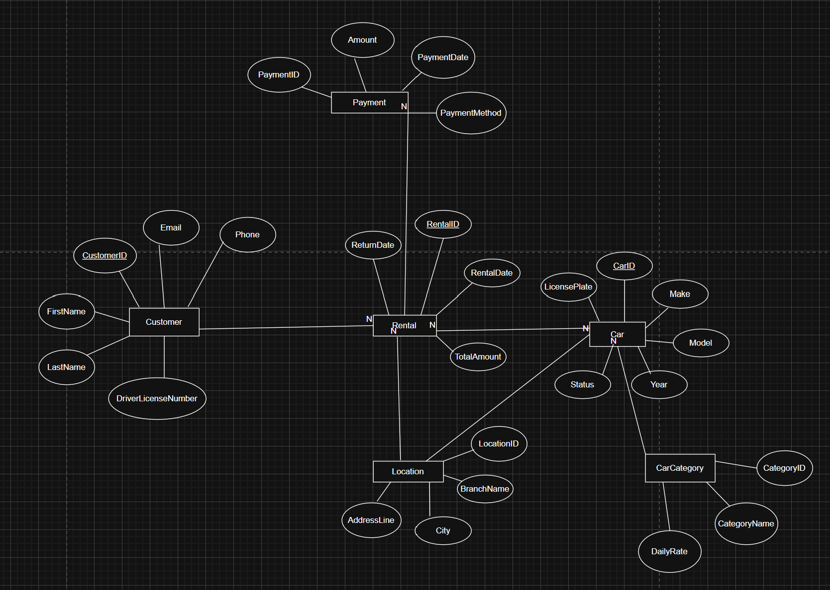

This ER diagram introduced in this segment serves as the logical blueprint for the whole system, depicting the business rules that dictate the entire car rental process. The use of the conceptual design phase before the actual database creation ensures that all the practical considerations, such as knowing which vehicle is at which branch and computing the charge depending on the classification, are taken care of without introducing any inconsistencies within the database. The diagram employs the use of Chen notation, in which rectangles denote the primary data items, circles identify the attributes, and diamonds illustrate the activities linking these entities.

Another important decision taken in the construction of this model is that of the placement of the Rental entity in the middle of the model. The Rental entity is connected to almost all other objects within the model, which is consistent with the "Total Participation" principle – that is, a rental would not be possible without a customer being registered, having access to a vehicle, and the location being verified. The $1:N$ (one-to-many) relationships shown on these connection lines indicate that this model is geared toward a company that is growing. For instance, the relationship between Customers and Rentals shows that even though a customer registers his or her personal details only once, he or she can rent cars as many times as necessary.
The model also introduces the concept of a Weak Entity through the Payment table. This is a critical design choice for an honors-level project, as it demonstrates an understanding of existential dependency; a payment record cannot exist in a vacuum and must always refer back to a specific RentalID. Visually, this is represented by the double-line borders, signaling to the database engine that if a rental record were to be deleted, its associated payment history must be handled accordingly to maintain referential integrity.
Lastly, the multi-faceted nature of the Location entity with both Cars and Rentals means that there is an opportunity for the company to coordinate its fleets through the use of the various locations. Through the naming of relations through diamonds to "Stocks" or "Pickup Point," it is clear that a location is not merely a static address but rather an actual location from which there is movement of stock. In addition, it is the precision of this model that allowed the programming of normalized database tables within SQL Server.
4. Diagram of tables
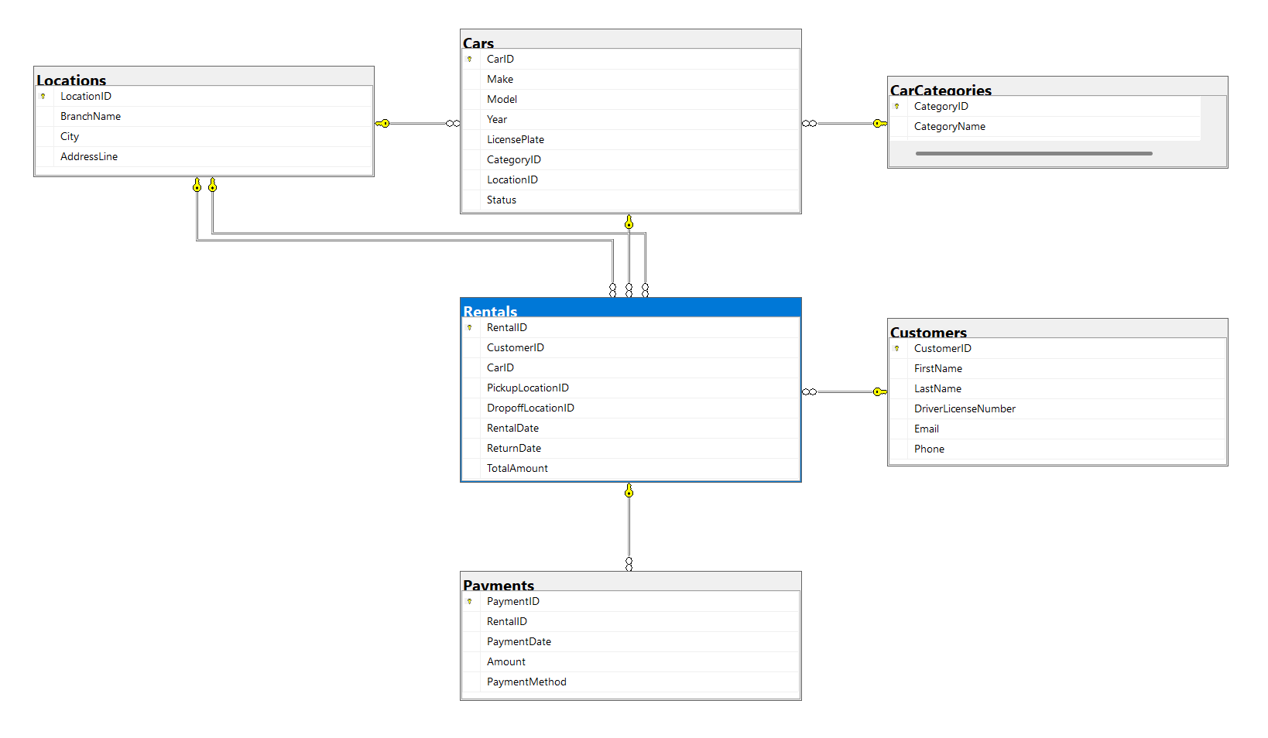
This is a diagram indicating how the database scheme of car rentals looks like physically on SQL Server Management Studio (SSMS). While the ER diagram describes the logical aspect of the business rules, this particular model describes the physical side by explaining how information will actually be organized within the database. This diagram is going to play an essential role in the translation process from concept to reality.
From the above illustration, PK and FK have been employed to establish robust links between databases. The yellow colored key is found near the unique id of the database, for example, CarID or RentalID, ensuring that all entries within the table are accessible. These lines represent the establishment of referential integrity.
A distinctive feature of this physical schema is the centralized role of the Rentals table, which functions as a bridge between all other entities. It contains multiple foreign keys that point to the Customers, Cars, and Locations tables, allowing the system to aggregate complex information like which customer rented which car from which branch into a single transaction record. The use of the "infinity" symbol (∞)on the relationship lines indicates a 1:N mapping, confirming that the physical structure supports a high volume of transactions while maintaining a streamlined, normalized architecture.
This diagram gives us a complete map on how things should be for any future DBAs or developers who will handle this project. This shows that the whole system is completely normalized up to the Third Normal Form (3NF), which means that redundancy will be minimal and thus the database will be optimized for storage and quick queries. This physical structure will give a guideline for the SQL, views, and permissions in the operations of the car rental system.
5. Refrences
1. Elmasri, R., & Navathe, S. B. (2015). Fundamentals of Database Systems (7th ed.). Pearson.
2. Microsoft Corporation. (2026). Transact-SQL (T-SQL) Reference & SQL Server Management Studio Documentation. Microsoft Learn.
3. Silberschatz, A., Korth, H. F., & Sudarshan, S. (2019). Database System Concepts (7th ed.). McGraw-Hill Education.

